**Image Processing**

**(Ex-Mtech AI/ML )**

**Test 1, Date: June 10th, 2023 Time : 3.00 pm to 4.15 pm**

Q1. Given an original image and its two transformed versions A and B below: [3] 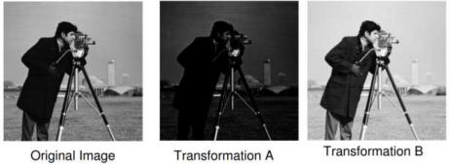(a) Show the possible ‘general’ shape of the intensity transformation functions that lead original image to images A and B.

(b) Also give explanation for shapes drawn in (a) and the effect it has produced in 1-2 lines only.

Q2. Given a small segment of image below: [2]

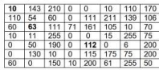

Let v = {0,10, 50, 54, 60, 63, 75, 106, 110}.

Is there an m-connecting path between cell (1,1) with value 10 and the cell (5,5) with value 112. Q3. Given an image with gray level values between (0-7) and histogram below: [5]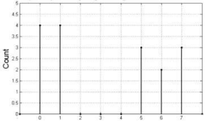

a. What are the total number of pixels and size of this image ?

b. If we transform the **intensity of the original pixels** to **new intensity resulted by setting their most significant bit to 1**, then how will the new histogram look like. For example input value 2 : 010 -> transforms to 110-> 6 .

c. Compute threshold (T) such that T = m where m is the mean gray level value of original image. Apply this threshold and draw new histogram for output binary image.

Note: (show computation also for each part of the answer)